
P.E.S. COLLEGE OF ENGINEERING MANDYA, KARNATAKA
Ph: 08232-220043, Ext: 289
Fax: 08232-222075
Email:pesce.teqipcell@gmail.com
OFFICE OF THE TEQIP CELL

INVITATION FOR QUOTATION

TEQIP-III/2018/pcem/Shopping/12 09-Jan-2018

To,

Madeena Industires  Guthal road, Mandya, Karnataka, 571401 | G.P. Enterprises  V.V. Road,, Mandya, Karnataka, 571401 | SDM Associates  #Q220, 1st Main, Hebbal Industrial Estate, Mysuru, Karnataka, 570016
Saarthy Engineering Works  #65, FEF4, 2ND Main, 3rd Cross, Hootagalli Industrial Area, Mysuru, Karnataka, 570018 | Vision Tech  #162, MUDA Employees layout, Paduvana road, Kuvempunagar, Mysuru, Karnataka, 570023 | Pathange Collections  #29/3, Sri lakshmi Venkateshwara Complex,  1st Main, V V Puram,, Mysuru, Karnataka, 570002
DGM Associates  #1329, Gowrithanaya, Near Siddarameshwara Choultry, Bogadi,, Mysuru, Karnatak | Officetech  #6/8, Commanders Place, Near Richmond Circle, Raja Ram Mohan Roy Road, Bangalore, Karnataka, 560025

Sub: Invitation for Quotations for supply of Goods

Dear Sir,
- You are invited to submit your most competitive quotation for the following goods with item wise detailed specifications given at Annexure I,

Sr. No | Brief Description | Quantity | Delivery Period(In days) | Place of Delivery | Installation Requirement (if any)
1 | Almirah Big | 12 | 60 | Office of the TEQIP Cell, PES College of Engineering, Mandya - 571 401 KARNATAKA
2 | Almirah Small | 12 | 60 | Office of the TEQIP Cell, PES College of Engineering, Mandya - 571 401 KARNATAKA
3 | Computer Chair | 85 | 60 | Office of the TEQIP Cell, PES College of Engineering, Mandya - 571 401 KARNATAKA
4 | Computer Table | 30 | 60 | Office of the TEQIP Cell, PES College of Engineering, Mandya - 571 401 KARNATAKA
5 | Library stock rack 8 | 6 | 60 | Office of the TEQIP Cell, PES College of Engineering, Mandya - 571 401 KARNATAKA

- Government of India has received a credit from the International Development Association (IDA) towards the cost of the Technical Education Quality Improvement Programme[TEQIP]-Phase III Project and intends to apply part of the proceeds of this credit to eligible payments under the contract for which this invitation for quotations is issued.
- Quotation,
  - The contract shall be for the full quantity as described above.
  - Corrections, if any, shall be made by crossing out, initialing, dating and re writing.
  - All duties and other levies payable by the supplier under the contract shall be included in the unit price.
  - Applicable taxes shall be quoted separately for all items.
  - The prices quoted by the bidder shall be fixed for the duration of the contract and shall not be subject to adjustment on any account.
  - The Prices should be quoted in Indian Rupees only.
- Each bidder shall submit only one quotation.
- Quotation shall remain valid for a period not less than 55 days after the last date of quotation submission.
- Evaluation of Quotations,
The Purchaser will evaluate and compare the quotations determined to be substantially responsive i.e. which
  - are properly signed ; and
  - confirm to the terms and conditions, and specifications.
- The Quotations would be evaluated for all items together.
- Award of contract:
The Purchaser will award the contract to the bidder whose quotation has been determined to be substantially responsive and who has offered the lowest evaluated quotation price.
  - Notwithstanding the above, the Purchaser reserves the right to accept or reject any quotations and to cancel the bidding process and reject all quotations at any time prior to the award of contract.
  - The bidder whose bid is accepted will be notified of the award of contract by the Purchaser prior to expiration of the quotation validity period. The terms of the accepted offer shall be incorporated in the purchase order.
- Payment shall be made in Indian Rupees as follows:
Delivery and Installation - 0% of total cost
Satisfactory Acceptance - 100% of total cost
- All supplied items are under warranty of 12 months from the date of successful acceptance of items.
- You are requested to provide your offer latest by 15:30 hours on 24-Jan-2018 .
- Detailed specifications of the items are at Annexure I.
- Training Clause (if any) Not Needed
- Testing/Installation Clause (if any) Installation and testing to the satisfaction of the Departmental technical committee
- Information brochures/ Product catalogue, if any must be accompanied with the quotation clearly indicating the model quoted for.
- Sealed quotation to be submitted/ delivered at the address mentioned below,
Office of the TEQIP Cell, PES College of Engineering, Mandya - 571 401 KARNATAKA,
Phone: 08232 220043 Ext: 289
17. We look forward to receiving your quotation and thank you for your interest in this project.

Nodal officer Principal
Procurement

Annexure I
Sl. No. | Description | Specification | Qty
1 | Almirah Big  78”x36”19” | 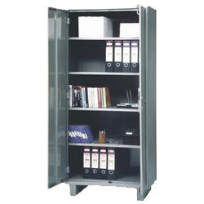 | 12 Nos.
2 | Almirah Small  54”x36”x18” |  | 12 Nos.
3 | Computer Chairs  Fiber Chair (Neelkaml Model) with arm & good quality, Model No 2155 | 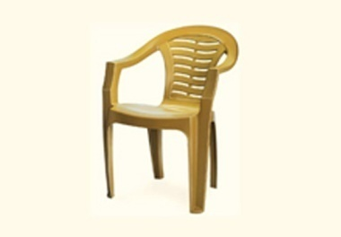 | 85 Nos.
4 | Computer Table  Table top & round 19mm BB plywood with 1mm branded formica lamination. All round teakwood beading with polish. Provision for placing two computers, 2 keyboards & leg rest as shown. | 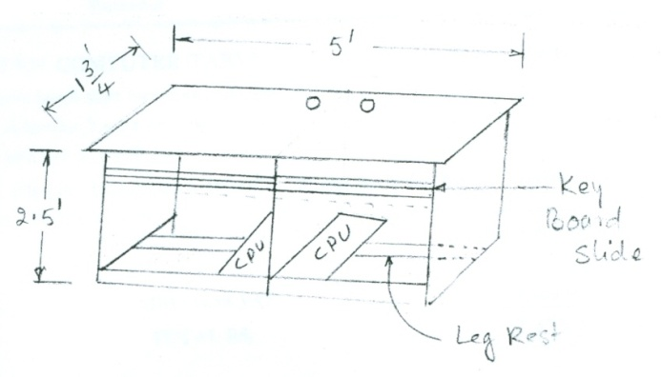 | 30 Nos.
5 | BOOK STACKS: Double Side Steel type  Double faced Open access book stacks of 18 or 20 gauge with 14 shelves (7x7) each sides, consisting end frame and range indicators, fully powder coated  (Main frame – 1 No.  Additional frame – 3 Nos.)  Size = 7.5 ft H x 3ft W x22 D | 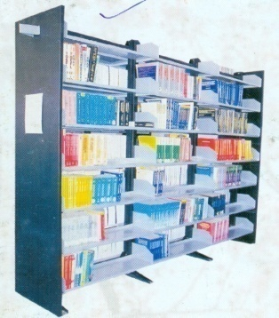 | 6 Nos.

FORMAT FOR QUOTATION SUBMISSION
(In letterhead of the supplier with seal)
Date: _______________
To:
____________________________
____________________________
Sl. No. | Description of goods (with full Specifications) | Qty. | Unit | Quoted Unit rate in Rs.  (Including Ex Factory price, excise duty, packing and forwarding, transportation, insurance, other local costs incidental to delivery and warranty/ guaranty commitments) | Total Price  (A) | Sales tax and other taxes payable
 |  |  |  |  |  | In  % | In figures (B)
Total Cost

Gross Total Cost (A+B): Rs. ________________
We agree to supply the above goods in accordance with the technical specifications for a total contract price of Rs. ———————— (Amount in figures) (Rupees ————————amount in words) within the period specified in the Invitation for Quotations.

We confirm that the normal commercial warranty/ guarantee of ——————— months shall apply to the offered items and we also confirm to agree with terms and conditions as mentioned in the Invitation Letter.

We hereby certify that we have taken steps to ensure that no person acting for us or on our behalf will engage in bribery.

Signature of Supplier
Name: ____________________
Address: __________________
Contact No: ________________

